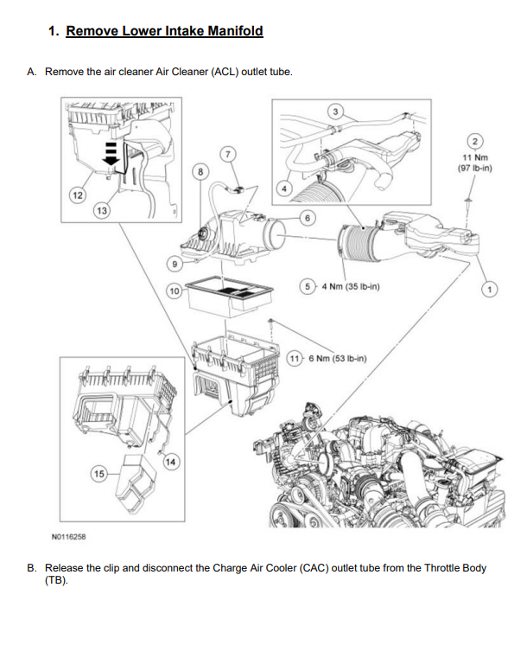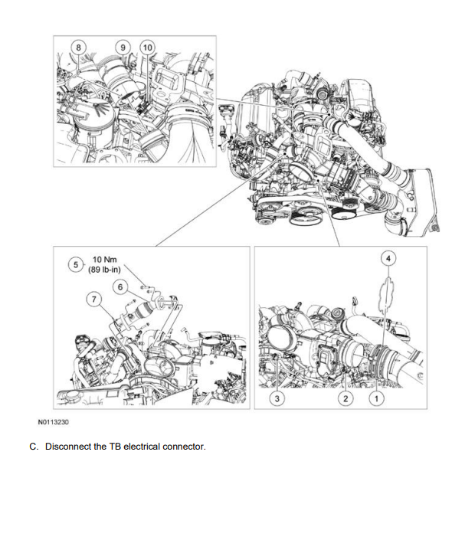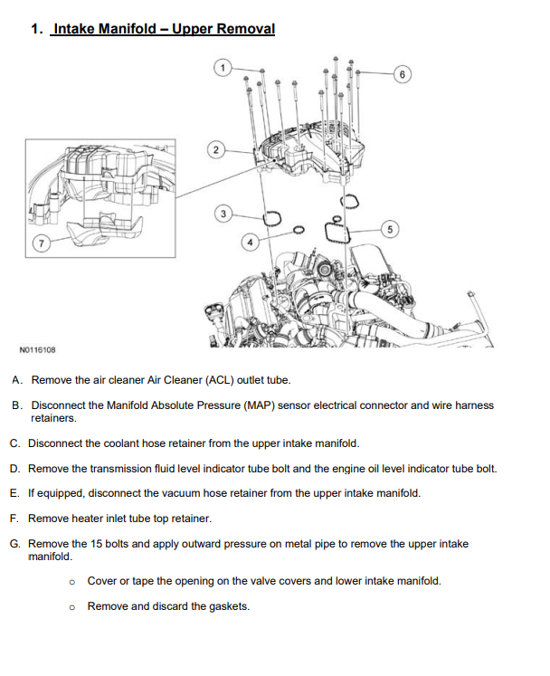

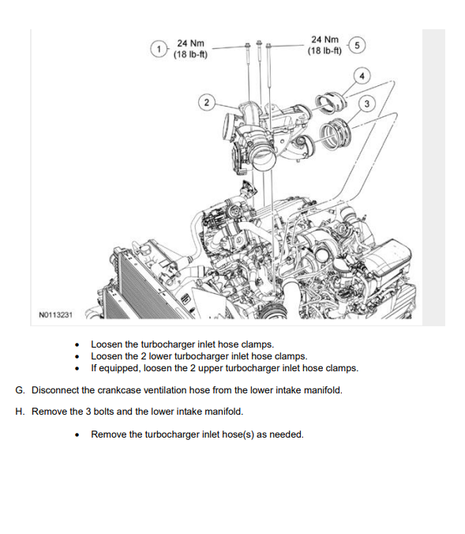

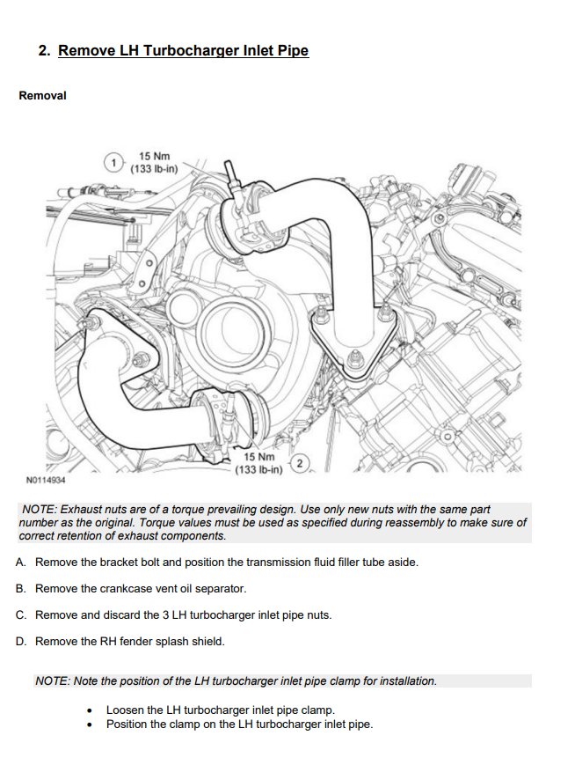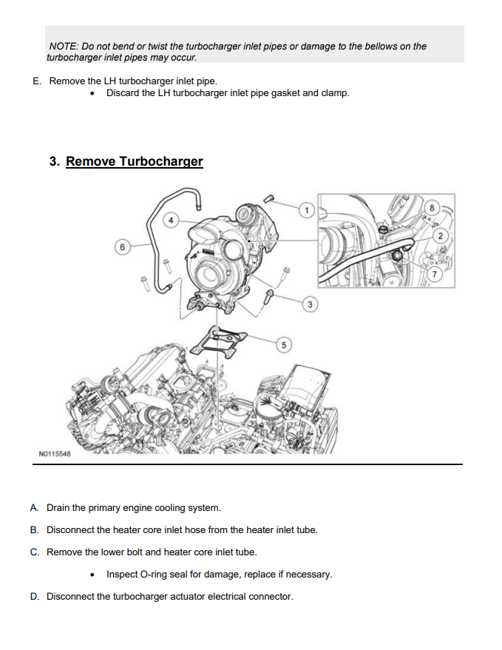

No Limit Fabrication 11-14 VGT Trubo Drop In Install

- Be sure that all surfaces are all prepped and cleaned before installing the new turbo and gasket.
- Transfer OEM heat shield from your old turbo to the new unit using the supplied hardware.
- Use the supplied pedestal to block gasket and you can now set your no limit turbo in place you will want to install the pedestal bolts going in a star pattern starting with the driver side front bolt torquing them to 42ftlbs.
- Reinstall the driver and passenger side up pipes you can install the clamp and hardware as well, making sure they are tight.
- You can now reinstall the downpipe securing it to the back of the turbo and reinstalling the 10mm bolt tying it to the rear engine cover. You can also reattach the 2 lower bolts connecting the bottom section of the downpipe to the remaining exhaust.
- With the turbo installed and everything tightened and torqued down you can now begin to install the extra parts supplied with the turbo. The billet block is used as a coolant spacer so that the supplied coolant line can be used properly.
- You will then use the supplied black cap and clamp to close the oval inlet port on the cast aluminum intake manifold.
- Once all that is installed you can then reinstall the upper and lower intake, hot side pipe, and intake.
- Lastly refill coolant & oil start the truck and inspect for leaks.

