No Limit Fabrication 2020-2024 Ford 6.7 Powerstroke Downpipe Install

- You will begin by removing the inner fender well of the passenger side front wheel to gain access to the factory downpipe and downpipe hardware.

- With the liner removed you are going to want to start with loosening the clamp that secures the lower section of the downpipe to the upper section. Once that is loose enough you can then remove the 2 bolts securing the downpipe to the exhaust down below.

- The last bit of hardware you are going to need to remove are the 2 nuts and 2 studs mounting the lower section of the downpipe to the passenger side head. With those removed it’s just a matter of prying and wiggling the downpipe until it pops off the upper section. Once disconnected you may need to remove one or 2 exhaust hangers to push the exhaust out of the way to give the downpipe enough room to drop out the bottom. 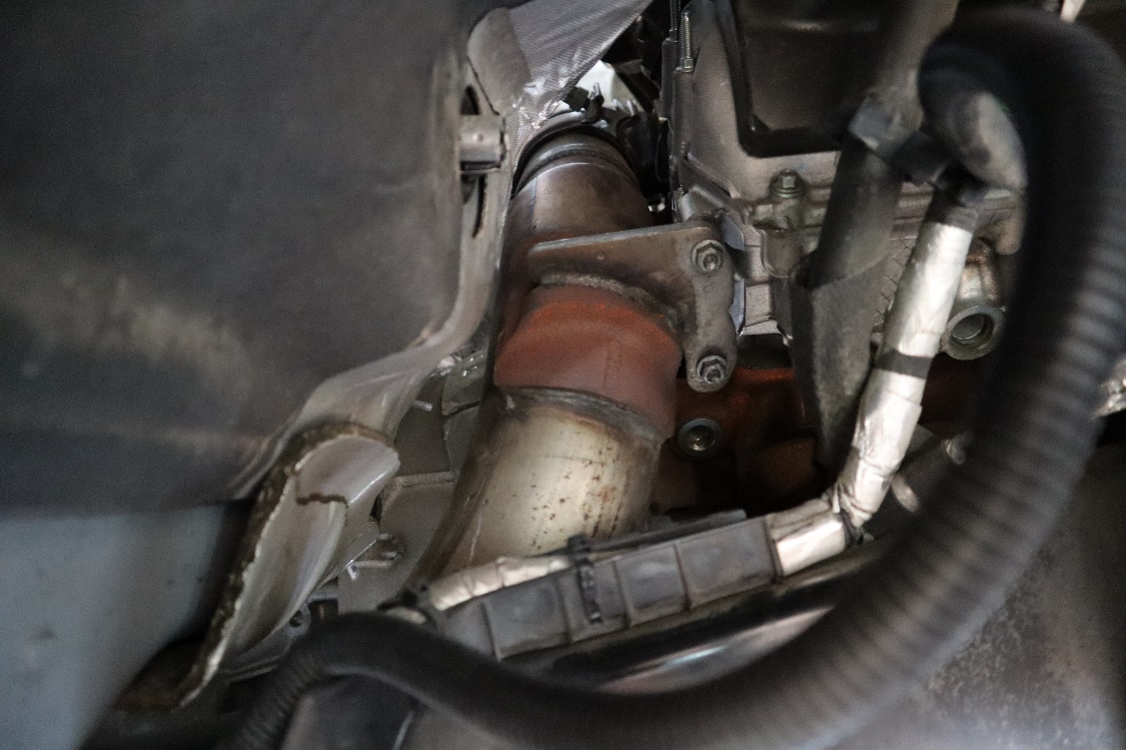

- Now that you have the bottom section out of the way you can begin to attack the upper. Start with removing the downpipe clamp that connects the upper to the back of the turbo by loosening the 11mm nut on the Tbolt Clamp.

- Once the downpipe clamp is removed or at least not connected anymore you can remove the 10mm bolt that holds the upper to the rear cover of the engine. With that removed you can begin installing the No Limit 4” Stainless Steel Downpipe essentially doing the exact same thing but in reverse.

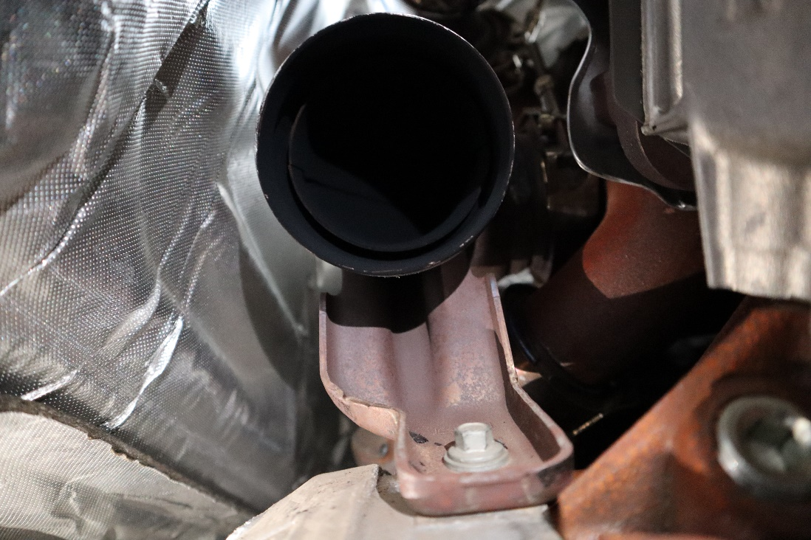

- Mount the upper section to the back of the turbo with your downpipe clamp but leave the clamp slightly loose so that you can rotate the upper. Now install the 10mm bolt back into the rear cover holding the downpipe in place. Once the bolt is in and tight you can then tighten the 11mm nut on the downpipe clamp.

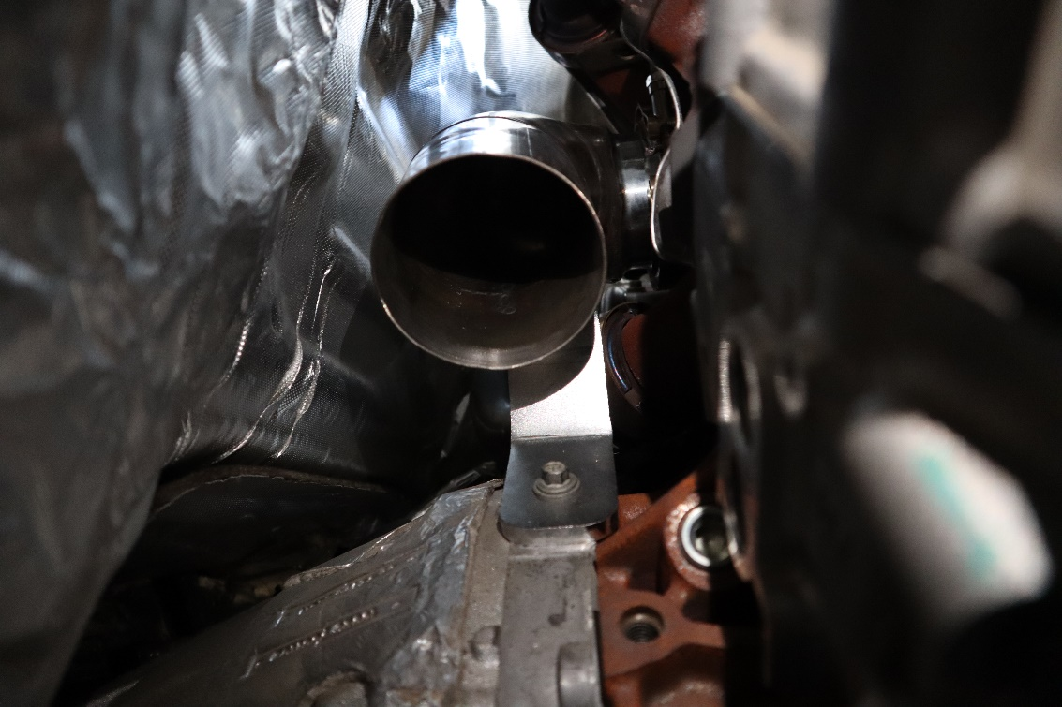

- Now you can install the lower section. Begin by installing the supplied band clamp onto the downpipe with the nut oriented so that it will be facing the firewall. Now you can slide the lower into place and onto the upper section. Once in place you can begin to reinstall the 2 studs first then the 2 nuts to mount it in place.
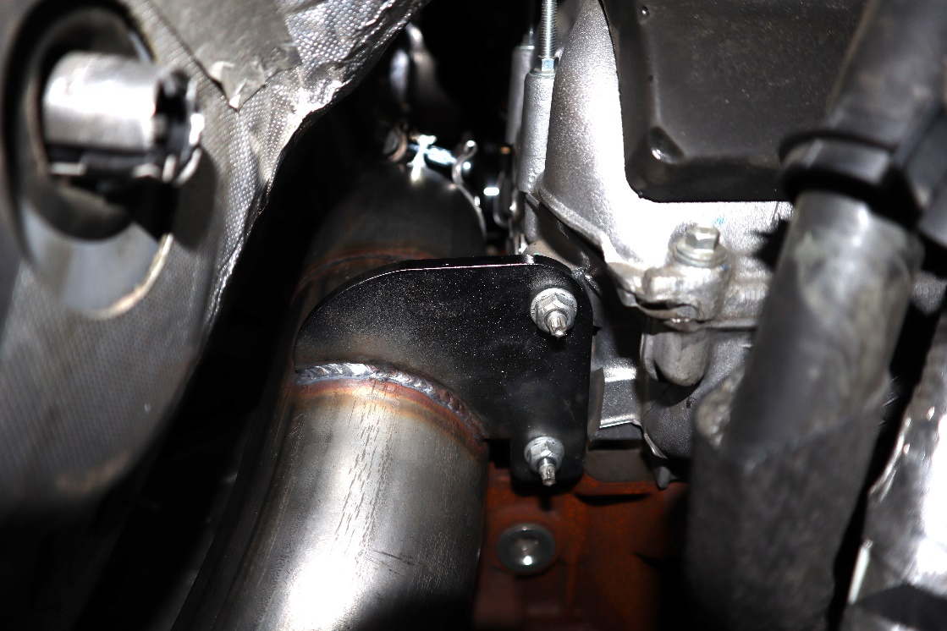

- With the nuts and studs tight, you can begin to tighten the clamp that secures and seals the lower section to the upper. You will want to repeat this step after 500 miles to make sure the clamp is still tight after a couple heat cycles.
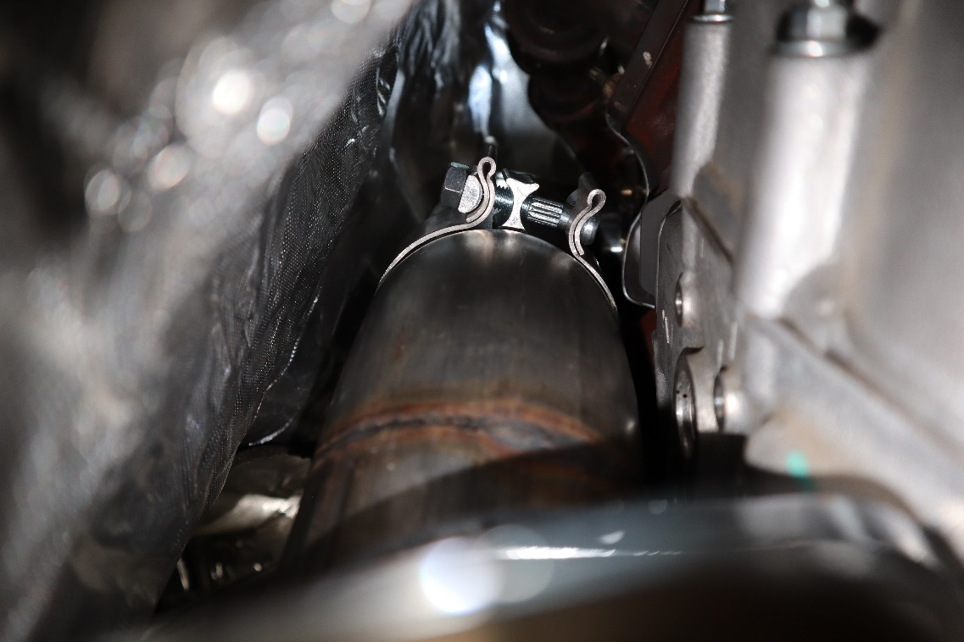

- With the 2 sections mated and everything is tight you can reconnect your exhaust to your No Limit Fabrication Stainless Steel Downpipe. We recommend checking for leaks and once you verify there aren’t any to reinstall your fender liner.
