Shift On The Fly Installation Instructions

SOTF cable must be installed before loading SOTF ready tunes.

1. Locate Wire harness and grommet on driver side firewall directly behind parking brake pedal.

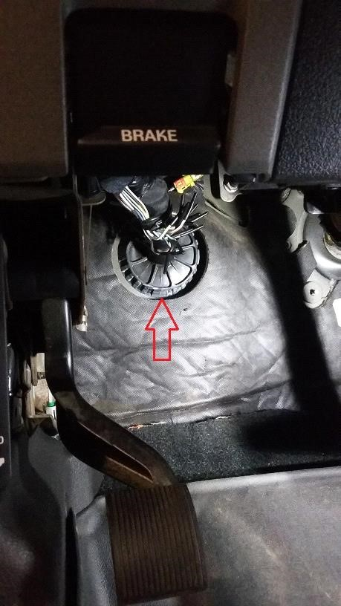

1. Make an incision in the grommet large enough to fit the SOTF cable through.

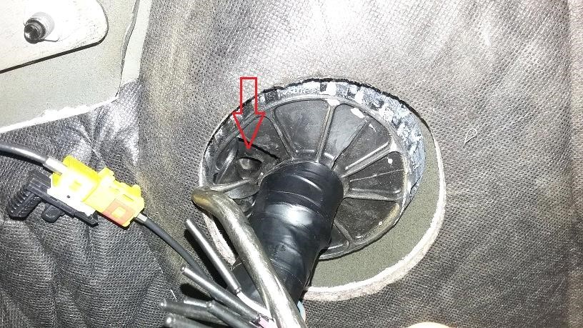

1. Locate the other side of the grommet in the engine compartment (next to the brake booster) and cut the tip of the protruding rubber cylinder.

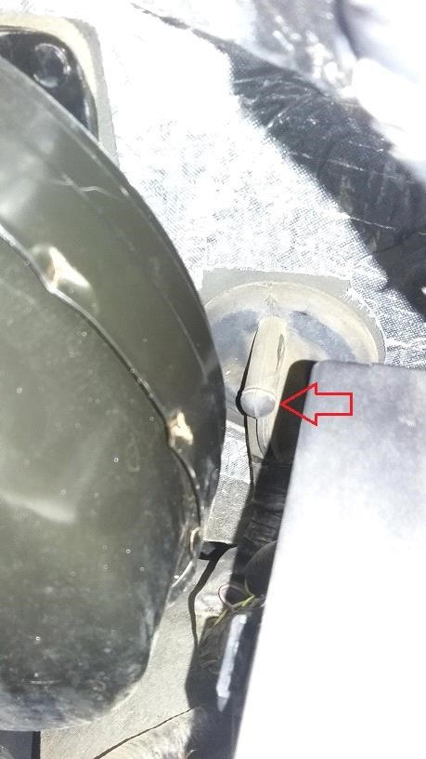

1. Route the shift on the fly cable through the grommet from inside cab to engine compartment.

Tip: Taping terminals together will make it easier to insert through the firewall grommet

1. Connect the shift on the fly cable terminals to the connector with the exposed copper wire facing up while the connector housing is positioned as depicted in picture below. It does not matter which terminal goes in which hole. Be sure the terminals fully seat in terminal housing and click in place.

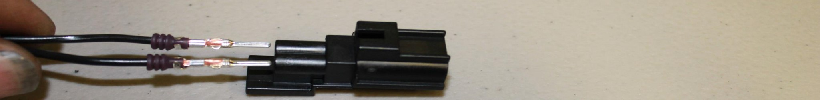

1. Locate the charge air cooler temperature sensor and disconnect it.

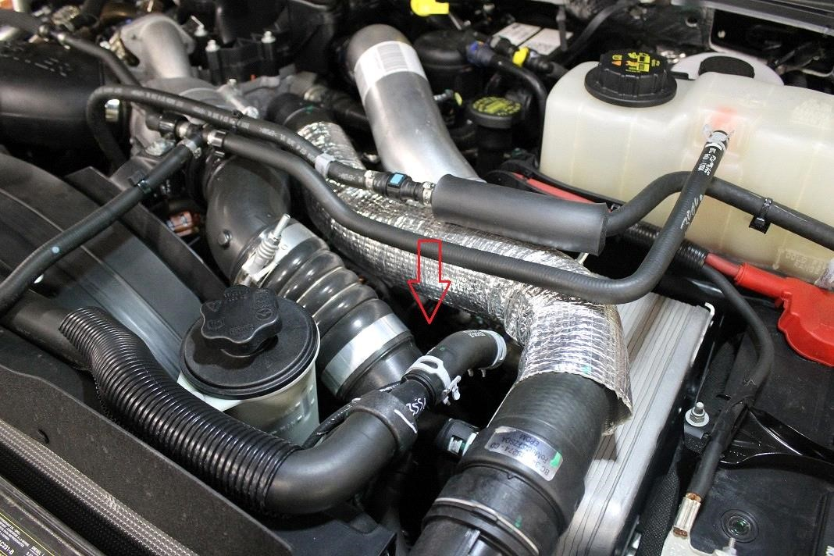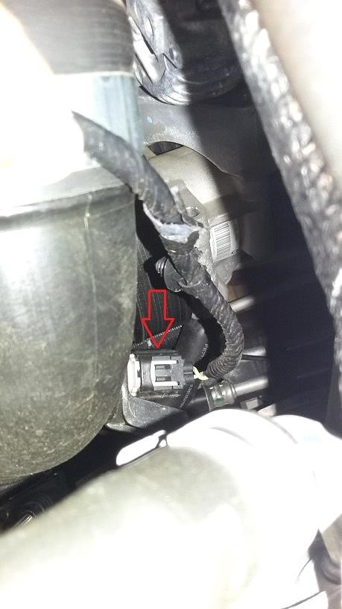

1. Reroute the charge air temperature sensor connector under the upper radiator hose and plug it into the SOTF cable adjacent to the battery (as depicted below). Route the SOTF cable between the battery and fender. Pull any excess slack in the SOTF cable from the engine compartment into the cab.

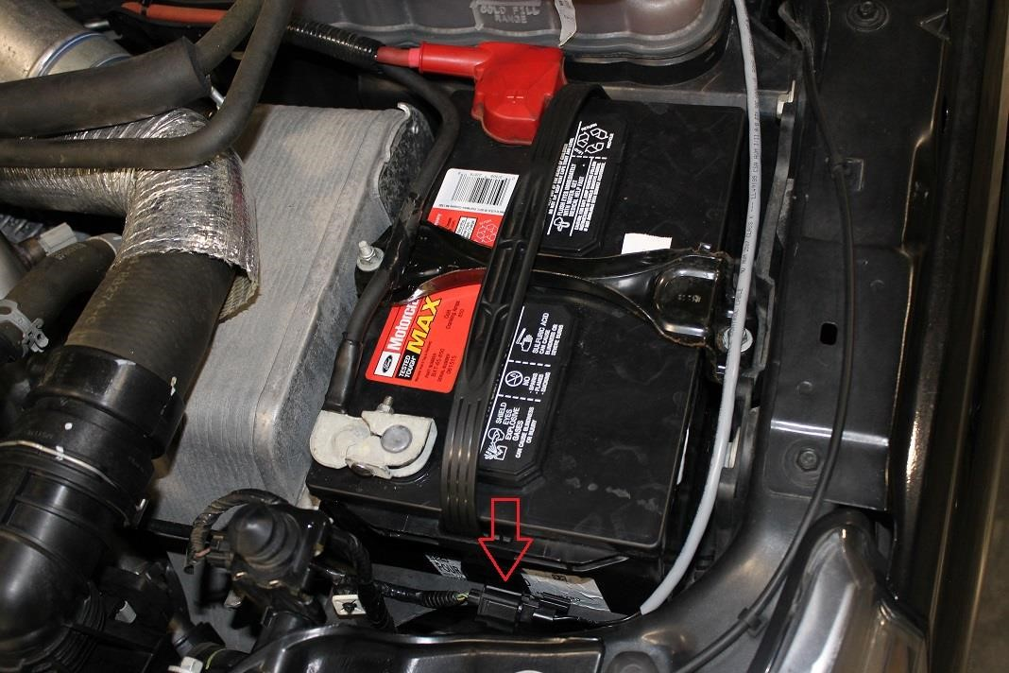

# A few key things to note

If the cable is not plugged in properly or a connection is not made, diagnostic trouble code "P3900" will be thrown for "SOTF Cable

Disconnected". If the cable or switch is damaged resulting in a shorted circuit, diagnostic trouble code "P3901" for "SOTF Cable Short to Ground".

If the cable is disconnected or has a poor connection, the truck will default to the lowest HP setting (400HP, for 2015 and 2016MY trucks).